


DEPARTMENT OF INFORMATION TECHNOLOGY
Academic Year: 2024 – 2025 [ODD SEM]

YEAR/SEM: III - /V BATCH: 2022 – 2026

OS LAB MANUAL

MANAKULA VINAYAGAR INSTITUTE OF TECHNOLOGY
Kalitheerthalkuppam, Puducherry.
Academic Year 2024-2025 (ODD SEM)

Year/Sem: III/V Batch: 2022-2026

OPERATING SYSTEM LAB-IT-P52

Sl.no | LIST OF EXPERIMENT
1 | BASIC COMMANDS IN LINUX
2 | SHELL PROGRAMMING  - Even or odd  - Echo command  - String comparison  - Greatest of three numbers  - Swapping of two numbers  - Password checking
3 | System calls of Unix / Linux operating  system:  - Fork System call  - Dirent System call  - Stat system call
4 | I/O system calls of UNIX operating system  - Read system call  - Write system call
5 | System calls program of Unix / Linux commands like ls, grep,  - Grep system call  - Ls system call
6 | Scheduling algorithms CPU and Disk  - FIFO  - SJF  - PS  - RRS
7 | Synchronization problems using Semaphore.  - Dinning Philosopher
8 | Basic memory management schemes  - Best fit  - first fit  - Worst fit
9 | virtual memory management schemes  - FIFO  - LRU
10 | Disk Scheduling  - FCFS  - Shortest Seek Timer First  - Scan
Additional Experiments
11 | Implement the Producer – Consumer problem using semaphores (using UNIX system calls).
12 | Implement an Bankers algorithm for Dead Lock Avoidance
13 | Implement an Bankers Algorithm for Dead Lock Prevention

Ex No. 1. BASIC COMMANDS IN LINUX
AIM
To study the basic commands in Linux operating system.
COMMANDS
The following are the commands to be studied:
1. date
2. date +%m
3. date +%h
4. date +%d
5. date +%y &date +%Y
6. date +%H
7. date +%M
8. date +%S
9. cal
10. cal year
11. echo “message”
12. who
13. whoami
14. mkdir
15. cd directory name
16. rmdir directory name
17. cd
18. ls
19. cat>filename
20. cat filename
21. cp source file destination file
22. mv source file destination file
23. cut -c column number file name
24. rm file name
25. head -no. of rows file name
26. tail -no. of rows file name
27. sort file name
28. wc file name
Explanation for the above commands is given below.
1. TASK : To display the system date and time
COMMAND : date
SYNTAX : date
EXPLANATION: This command displays the current system date and time on the screen.
OUTPUT :
[exam1@local host ~]$date
Thu Nov 27 10:37:05 IST 2013

2. TASK : To display the current month.
COMMAND : date
SYNTAX : date +%m
EXPLANATION: This command displays the current month on the screen.
OUTPUT :
[exam1@local host ~]$date +%m
11

3. TASK : To display the name of the current month.
COMMAND : date
SYNTAX : date +%h
EXPLANATION: This command displays the name of the current month on the screen
OUTPUT :
[exam1@local host ~]$date + %h
Nov
4. TASK : To display the current system date.
COMMAND : date
SYNTAX : date +%d
EXPLANATION: This command displays the current system date on the screen.
OUTPUT :
[exam1@local host ~]$date +%d
27

5. TASK : To display the current system (year)
COMMAND : date
SYNTAX : date +%y & date +%Y
EXPLANATION: This command displays the current system year on the screen.
OUTPUT :
[exam1@local host ~]$date +%y
13
[exam1@local host ~]$date +%Y
2013

6. TASK : To display the current system time.
COMMAND : date
SYNTAX : date +%H
EXPLANATION: This command displays the current system time (in hour) on the screen.
OUTPUT :
[exam1@local host ~]$date +%H
10

7. TASK : To display the current system time.
COMMAND : date
SYNTAX : date +%M
EXPLANATION: This command displays system time (in min) on the screen.
OUTPUT :
[exam1@local host ~]$date +%M
49

8. TASK : To display the current system time.
COMMAND : date
SYNTAX : date +%S
EXPLANATION: This command displays the current system time (in sec) on the screen.
OUTPUT :
[exam1@local host ~]$date +%S
50

9. TASK : To display the calendar of the current month.
COMMAND : calendar
SYNTAX : cal (or)cal -1
EXPLANATION: This command displays the calendar of the current month on the screen.
-1 Display single month output. (This is the default.)
-3 Display prev/current/next month output.
-s Display Sunday as the first day of the week. (This is the
default.)
-m Display Monday as the first day of the week.
-j Display Julian dates (days one-based, numbered from January 1).
-y Display a calendar for the current year.
OUTPUT :
[exam1@local host ~] $ cal
November 2013
Su Mo Tu We Th Fr Sa
1 2
3 4 5 6 7 8 9
10 11 12 13 14 15 16
17 18 19 20 21 22 23
24 25 26 27 28 29 30
[exam1@localhost ~]$ cal -3 9 2013
August 2013 September 2013 October 2013
Su Mo Tu We Th Fr Sa Su Mo Tu We Th Fr Sa Su Mo Tu We Th Fr Sa
1 2 3 1 2 3 4 5 6 7 1 2 3 4 5
4 5 6 7 8 9 10 8 9 10 11 12 13 14 6 7 8 9 10 11 12
11 12 13 14 15 16 17 15 16 17 18 19 20 21 13 14 15 16 17 18 19
18 19 20 21 22 23 24 22 23 24 25 26 27 28 20 21 22 23 24 25 26
25 26 27 28 29 30 31 29 30 27 28 29 30 31

10. TASK : To display the calendar of a year.
COMMAND : cal
SYNTAX : cal year
EXAMPLE : cal 2007
EXPLANATION: This command displays the calendar of the specified year.
OUTPUT :
[exam88@local host ~] $ cal 2012
It displays all the month of the year 2012

11. TASK : To display the user defined message
COMMAND : echo
SYNTAX : echo “message”
EXPLANATION: This command display on the screen the argument of the echo command.
OUTPUT :
[exam1@local host ~] $ echo “Hello”
Hello

12. TASK : To display the detail of all users.
COMMAND : who
SYNTAX : who
EXPLANATION : This command lists the information about all the users who have logged on that system.
OUTPUT :
[exam88@local host ~] $ who
exam80 pts/18 2013-01-23 14.48 <172.17.3.51>
exam18 pts/12 2013-01-23 14.39 <172.17.3.51>

13. TASK : To display the user detail.
COMMAND : who
SYNTAX :whoami
EXPLANATION : This command displays the information about the current user of the system on the screen.
OUTPUT :
[exam88@local host ~] $ whoami
exam88

14. TASK : To create directory.
COMMAND : make directory
SYNTAX :mkdir
EXPLANATION : This command is used to create a new directory with a specified name.
EXAMPLE : mkdir student
OUTPUT :
[exam88@local host ~] $ mkdir sun
[exam88@local host ~] $ ls
Palindrome.c palindrome.sh
Morn.text good sun

15. TASK : To change directory
COMMAND : change directory
SYNTAX : cd directory name
EXAMPLE : cd sun
EXPLANATION : This command is used to switch from one directory to another.
OUTPUT :
[exam88@local host ~] $ cd sun
[exam88@local host sun] $

16. TASK : To come out of sub-directory.
COMMAND : change directory
SYNTAX : cd
EXPLANATION : This command help in switching to the main directory.
OUTPUT :
[exam88@local host sun] $ cd
[exam88@local host ~] $

17. TASK : To delete a directory.
COMMAND : remove directory
SYNTAX : rmdir directory name
EXPLANATION : This command is used to delete the specified directory.
OUTPUT :
[exam88@local host ~] $ rmdir sun
[exam88@local host ~] $ cd sun
No such file or directory.

18. TASK : To list all the files and directories.
COMMAND : list
SYNTAX :ls
EXPLANATION : This command display all the files and directories of the system.
OUTPUT :
[exam88@local host ~] $ ls
Palindrome.c palindrome.sh
Morn.text good

19. TASK : To create a file.
COMMAND : cat
SYNTAX : cat > file name
EXAMPLE :cat> wind.txt
EXPLANATION : This command leads to the creation of a new file with the specified filename content.
OUTPUT :
[exam88@local host ~] $ cat> wind.txt
Hai good morning
Have a Nice Day
1]+ stopped cat > wind.txt
[exam88@local host ~] $ cat> moon.txt
Hello how are you.
Take care of ur Health.
2]+ stopped cat > moon.txt
20. TASK : To view a file
COMMAND : cat
SYNTAX : cat filename
EXAMPLE : cat wind.txt
EXPLANATION: This command displays the content of the specified files.
OUTPUT :
[exam88@local host ~] $ cat wind.txt
Hai good morning
Have a Nice Day

21. TASK : To copy a file
COMMAND : copy
SYNTAX : cp source file destination file
EXAMPLE : cp wind.txt moon.txt
EXPLANATION: This command produces a copy of the source file to be stored in the specified destination file of overwriting its previous content if exist.
OUTPUT :
[exam88@local host ~] $ cp wind.txt moon.txt
[exam88@local host ~] $ cat moon.txt
Hai good morning
Have a Nice Day
EXPLANATION: This command produces a copy of the source file to be stored in the specified destination file(by creating it) .
[exam88@local host ~] $ cp wind.txt star.txt
[exam88@local host ~] $ cat star.txt
Hai good morning
Have a Nice Day

22. TASK : To move a file.
COMMAND : move
SYNTAX : mv source file destination file
EXAMPLE : mv wind.txt moon.txt
EXPLANATION : This command moves the content of the source file to destination file. The content of the source file is deleted.
OUTPUT :
[exam88@local host ~] $ mv wind.txt moon.txt
[exam88@local host ~] $ cat wind.txt
No such file or directory.

23. TASK : To cut a column from a file.
COMMAND : cut
SYNTAX : cut -c column number filename
EXAMPLE : cut -c 5-10 star.txt
EXPLANATION : This command displays the character of particular column in the specified field.
OUTPUT :
[exam1@localhost ~]$ cut -c 5-10 star.txt
good m
a Nic

24. TASK : To delete a file.
COMMAND : remove
SYNTAX :rm filename
EXAMPLE : rm star.txt
EXPLANATION : This command deletes the specified file from the directory.
OUTPUT :
[exam88@local host ~] $ rm star.txt
[exam88@local host ~] $ cat star.txt
No such file or directory.
25. TASK : To retrieve a part of file (From the top).
COMMAND : head
SYNTAX : head no.of rows file name
EXAMPLE : head – 1 moon.txt
EXPLANATION: This command displays the specified no.of rows from the top of the file.
OUTPUT :
[exam88@local host ~] $ head -1 moon.txt
Hai good morning

26. TASK :To retrieve a part of file (From the bottom)
COMMAND : tail
SYNTAX : tail no of rows filename.
EXAMPLE : tail -1 moon
EXPLANATION: This command displays the given no.of rows from bottom of the file.
OUTPUT :
[exam88@local host ~] $ tail -1 moon.txt
Have a Nice Day

27. TASK : To sort the content
COMMAND : sort
SYNTAX : sort file name
EXAMPLE : sort moon.txt
EXPLANATION: This command helps in sorting the content of a file in ascending order.
OUTPUT :
[exam88@local host ~] $ sort moon.txt
Hai good morning
Have a Nice Day

28. TASK : To display no.of characteristics in a file.
COMMAND : word count
SYNTAX : wc file name
EXAMPLE : wc moon.txt
EXPLANATION : This command displays the no.of rows, words and character in the file.
- wc -l <filename> print the line count
- wc -m <filename> print the character count
- wc -L <filename> print the length of longest line
- wc -w <filename> print the word count
OUTPUT :
[exam88@local host ~] $ wc –l –w –m moon.txt (or)
[exam88@local host ~] $ wc moon.txt
2 7 33 moon.txt

RESULT
Thus the given basic Linux commands are performed successfully.
SHELL PROGRAMMING
EX NO: 2(A) EVEN OR ODD
AIM

To write a shell program to find the given number is even or odd number using VI editor.

ALGORITHM
Step1: Start the program.
Step2: Get the number from the user to find whether it is even of odd.
Step3: Compute the reminder value and assign it to r.
Step4: Check the r value, if r value is ‘0’ print it is even otherwise odd.
Step5: Stop the program.

SOURCE CODE
echo "ENTER THE NUMBER"
read n
r=$(($n%2))
if [ $r -eq 0 ]
then
echo "EVEN"
else
echo "ODD"
fi

OUTPUT

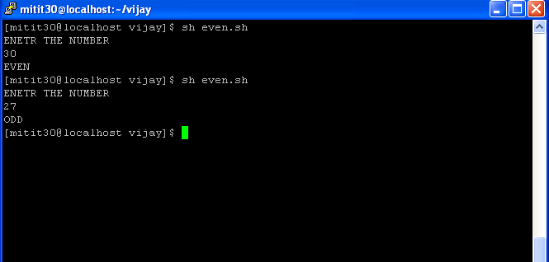

RESULT
Thus the program was executed successfully and the output was shown and verified.
EX NO: 2(B) ECHO COMMAND

AIM
To write a shell program to display the values using the echo command in VI editor.

ALGORITHM
Step1: Start the program.
Step2: display the list of commands as options for switch case.
Step 3: Get the value from the user to execute the desired command .
Step4: execute the command using the case statement.
Step5: stop the execution

SOURCE CODE
echo "1.WHO AM I?"
echo "2.WHO IS LOGGED ON?"
echo "3.DATE"
read n
case $n in
1) whoami;;
2) who;;
3) date;;
fi

OUTPUT

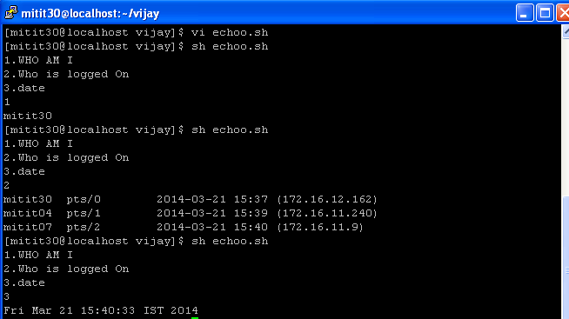

RESULT
Thus the program was executed successfully and the output was shown and verified.
EX NO: 2(C) STRING COMPARISON

AIM

To write a shell program to compare the two strings using VI editor.

ALGORITHM
Step1: Start the program.
Step 2: Get the two strings str1 and str2 from the user using read command
Step 3: Compare the two strings using the following condition,
if [ $str1 = $str2 ];
Step 4: If the condition is true print “the strings are equal” otherwise “the strings are not equal”.
Step 5: Stop the program

SOURCE CODE

echo "STRING 1"
read str1
echo "STRING 2"
read str2
if [ $str1 = $str2 ];then
echo "STRING $str1 AND $str2 ARE EQUAL"
else
echo "STRING $str1 AND $str2 ARE NOT EQUAL"
fi

OUTPUT

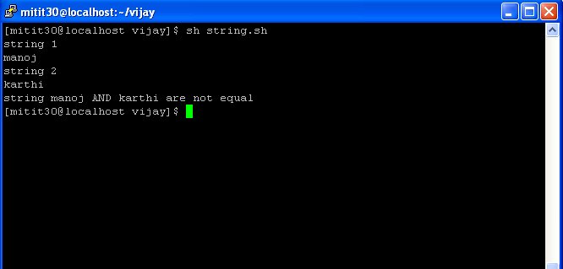

RESULT
Thus the program was executed successfully and the output was shown and verified.

EX NO: 2(D) GREATEST OF THREE NUMBERS

AIM

To write a shell program to find greatest number among three numbers using VI editor.

ALGORITHM
Step1: Start the program.
Step2: Get the 3 values from the user.
Step3: Compare the values using relational operators and determine the greatest among them.
Step4: Display the greatest number.
Step5: Stop the program

SOURCE CODE
echo "ENTER THE VALUES:"
read a b c
if [ $a -gt $b -a $a -gt $c ];then
echo "$a IS GREATEST"
elif [ $b -gt $c ];then
echo "$b IS GREATEST"
else
echo "$c IS GREATEST"
fi

OUTPUT

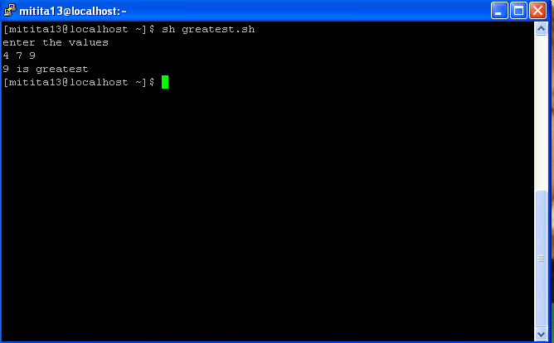

RESULT
Thus the program was executed successfully and the output was shown and verified.

EX NO: 2(E) SWAPPING OF TWO NUMBERS

AIM

To write a shell program to swap the given two numbers using VI editor.

ALGORITHM

Step1: Start the program.
Step2: Get two numbers from the user for swapping.
Step3: Display two numbers before swapping.
Step4: Swap the numbers by using the followingstatements,
a=$(($a+$b))
b=$(($a-$b))
a=$(($a-$b))

Step5: Display the numbers after swapping.
Step6: Stop the program.

SOURCE CODE
echo "ENTER THE TWO VALUES"
read a
read b
echo "BEFORE SWAPPING a=$a AND b=$b"
a=$(($a+$b))
b=$(($a-$b))
a=$(($a-$b))
echo "AFTER SWAPPING a=$a AND b=$b"

OUTPUT

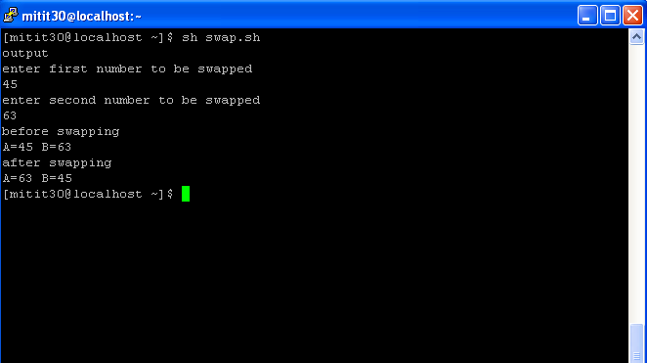

RESULT
Thus the program was executed successfully and the output was shown and verified.

EX NO: 2(G) PASSWORD CHECKING

AIM

To write a shell program to check the given password is valid or not using VI editor.

ALGORITHM
Step1: Start the program.
Step2: Initialize the password as “WELCOME”.
Step3: Get the password from the user for validation.
Step4: Compare the passwords using relational operator.
Step5: If they are equal, print it is valid otherwise invalid.
Step6: Stop the program.

SOURCE CODE
echo "PASSWORD CHECK"
pw="WELCOME"
echo "PLEASE ENTER THE PASSWORD"
read n
if [ $n = "$pw" ];then
echo "VALID PASSWORD"
else
echo "INVALID PASSWORD"
fi

OUTPUT
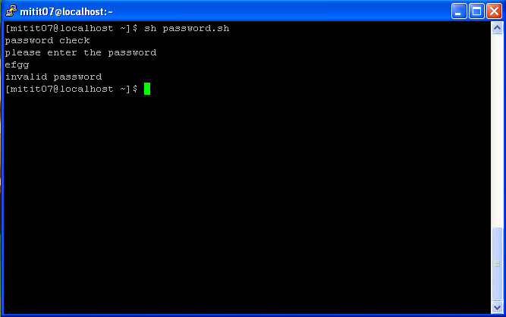

RESULT
Thus the program was executed successfully and the output was shown and verified.

SYSTEM CALLS

EX: NO: 3(A) FORK SYSTEM CALL

AIM:
To create a child process using Fork System Call

ALGORITHM
Step1: Start the program
Step2: make a system call fork()
Step3: If pid>0 then it is a parent process, print the fork id of parent and the child.
Step4: If pid=0 then it is a child process, Print the current fork id(child id).
Step5: If pid <0, error exists.
Step6: Stop the program.

PROGRAM
#include<stdio.h>
main()
{
int pid;
pid=fork();
printf("\n AFTER FORK CALLED\n");
if(pid==0)
{
printf("\n CHILD PROCESS IS EXECUTED \n");
printf("\n THE ID NUMBER OF THE CHILD PROCESS IS %d \n",getpid());
printf("\n THE ID NUMBER OF THE PARENT PROCESS IS %d",getppid());
}
else if(pid>0)
{
printf("\n PARENT PROCESS IS EXECUTED");
printf("\n THE ID NUMBER OF PARENT PROCESS IS %d\n",getpid());
}
else
{
printf("\n FORK PROCESS IS NOT EXECUTED");
}
}

OUTPUT:
[exam1@CSELAB1 ~]$ cc ex1.c
[exam1@CSELAB1 ~]$ ./a.out

AFTER FORK CALLED
CHILD PROCESS IS EXECUTED
THE ID NUMBER OF THE CHILD PROCESS IS 4505
THE ID NUMBER OF THE PARENT PROCESS IS 4504

AFTER FORK CALLED
PARENT PROCESS IS EXECUTED
THE ID NUMBER OF PARENT PROCESS IS 4504

RESULT
Thus the given program is executed successfully and the output was shown and verified.
EX: NO: 3(B) DIRENT SYSTEM CALL

AIM
To Display the Directory I-node and Directory name using Dirent System Call

ALGORITHM
Step 1: Start the program
Step 2: Create a dirent structure pointer variable, where the structure is pre-defined.
Step 3: Get the directory name from the user.
Step 4: If it exists display the file serial number and name of the entry using the structure members d_ino and d_name.
Step 5: Stop the program.

PROGRAM

#include<stdio.h>
#include<dirent.h>
struct dirent *dptr;
int main()
{
char buff[10];
DIR *dirp;
printf("\n\n ENTER THE DIRECTORY NAME:");
scanf("%s", buff);
dirp =opendir(buff);
if(dirp==NULL)
{
printf("The given directory does not exist");
}

while(dptr=readdir(dirp))
{
printf("%d\n",dptr->d_ino);
printf("%s\n",dptr->d_name);
}
closedir(dirp);
}

OUTPUT:
[exam1@CSELAB1 ~]$ cc dir.c
[exam1@CSELAB1 ~]$ ./a.out
ENTER DIRECTORY NAME:priya
7717059
.
7717069
raja
7720857
..
[exam1@CSELAB1 ~]$

RESULT
Thus the given program is executed successfully and the output was shown and verified.

EX: NO: 3(C) STAT SYSTEM CALL

AIM:
To display the status of the file by using Stat system call

ALGORITHM
Step1: Start the program.
Step2: Create a structure variable st for predefined structure stat.
Step3: make the system call stat().
Step4: print the inode number, identifier, block size, recently modified, and owner using the respective structure members st_ino,st_dev,st_blksize,st_mtime,st_uid.
Step5: stop the program.

PROGRAM

#include<sys/stat.h>
int main()
{
int s;
struct stat st;
s=stat("fork.c",&st);
if(s<0)
{
printf("\n use of stat() is unsuccessful ");
exit(0);
}
else
{
printf("\n INODE NUMBER IS %i",st.st_ino);
printf("\n IDENTIFIER OF THE DEVICE IS %d",st.st_dev);
printf("\n USER IDENTIFIER OF THE OWNER IS %u",st.st_uid);
printf("\n BLOCK SIZE FOR FILE SYSTEM IS %o",st.st_blksize);
printf("\n LAST FILE MODIFY IS %s\n",ctime(&st.st_mtime));
}
}
OUTPUT:
[exam1@CSELAB1 ~]$ cc stat1.c
[exam1@CSELAB1 ~]$ ./a.out

INODE NUMBER IS 7717070
IDENTIFIER OF THE DEVICE IS 64768
USER IDENTIFIER OF THE OWNER IS 705
BLOCK SIZE FOR FILE SYSTEM IS 10000
LAST FILE MODIFY IS Tue Aug 7 19:05:29 2007
[exam1@CSELAB1 ~]$

RESULT
Thus the given program is executed successfully and the output was shown and verified.

EX: NO: 4(A) READ SYSTEM CALL

AIM:
To read the content of the file by using Read system call

ALGORITHM
Step1: Start the program.
Step2: Get the name of the file using command line arguments.
Step3: Open the file in read only mode.
Step4: Display the contents of the file using read() function.
Step5: Close the file.
Step6: Stop the program.

SOURCE CODE:

#include <stdio.h>
#include <stdlib.h>
#include <fcntl.h>
main(int argc, char *argv[])
{
int fd,i;
char buf[100];
if (argc < 2)
{
printf("Usage: ./a.out <filename>\n");
exit(-1);
}
fd = open(argv[1], O_RDONLY);
if(fd == -1)
{
printf("%s file does not exist\n", argv[1]);
exit(-1);
}
printf("Contents of the file %s is : \n", argv[1]);
while(read(fd, buf, sizeof(buf)) > 0)
{
printf("%s", buf);
}
close(fd);
}

OUTPUT

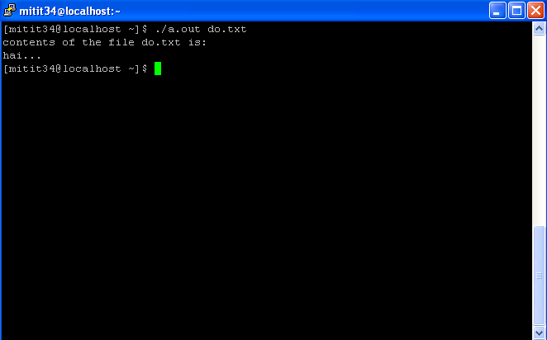

RESULT
Thus the given program is executed successfully and the output was shown and verified.

EX: NO: 4(B) WRITE SYSTEM CALL

AIM
To perform the write operation in a file using write system call

ALGORITHM
Step1: Start the program.
Step2: Get the filename to modify using command line arguments.
Step3: Open the file in append mode
Step4: update the content of the file using write() system call.
Step5: close the file
Step6: Stop the program.

SOURCE CODE:

#include <stdio.h>
#include <string.h>
#include <stdlib.h>
#include <fcntl.h>
main(int argc, char *argv[])
{
int fd, n, len;
char buf[100];
if (argc != 2)
{
printf("Usage: ./a.out <filename>\n");
exit(-1);
}
fd = open(argv[1], O_APPEND|O_WRONLY|O_CREAT, 0644);
if (fd < 0)
{
perror(argv[1]);
exit(-1);
}
while((n = read(0, buf, sizeof(buf))) > 0)
{
len = strlen(buf);
write(fd, buf, len);
}
close(fd);
}

OUTPUT

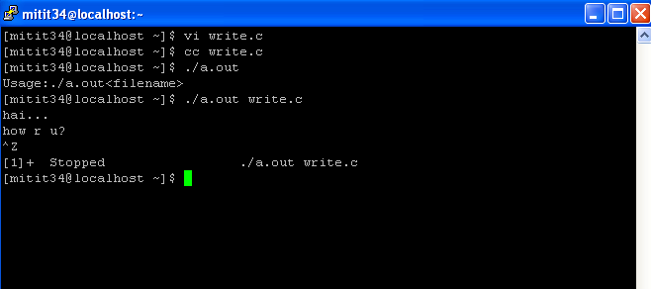

RESULT
Thus the given program is executed successfully and the output was shown and verified.

EX: NO: 5(A) GREP SYSTEM CALL

AIM:
To find the word in given program using Grep System call

ALGORITHM

Step1: Start the program
Step2: Get the file name and search string from command line arguments.
Step3: Then open the specified file in the read mode.
Step4: Compare each string of the file to the argv[2], if it exists print the line number then increment it.
Step5: repeat Step4 untill end of file.
Step6: Stop the program.

PROGRAM
#include<stdio.h>
#include<string.h>
#define buffer 1024
int main(int argc,char *argv[])
{
FILE *fp;
char fline[buffer];
char *newline;
int line=1;
if(argc!=3)
{
printf("Please use the following syntax \n");
printf("./a.out filename searchstring \n");
printf("Example: ./a.out test1.c print \n");
exit(1);
}
// argv[1] is filename
if(!(fp=fopen(argv[1],"r")))
{
printf("grep : Couldnot open file : %s\n",argv[1]);
exit(1);
}
while(fgets(fline,buffer,fp)!=NULL)
{
// argv[2] is search string
if(strstr(fline,argv[2])!=NULL)
{
printf("Line number: %d text: %s\n",line,fline);
}
line++;
}

}

OUTPUT

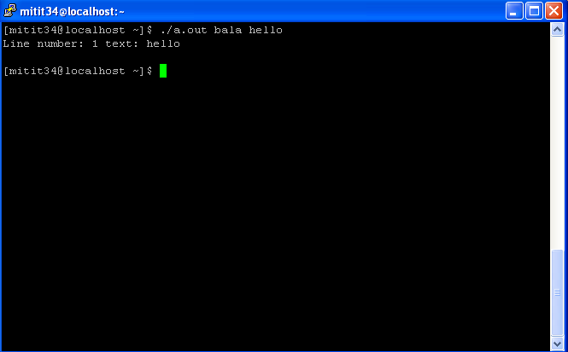

RESULT
Thus the given program is executed successfully and the output was shown and verified.
EX: NO: 5(B) LS SYSTEM CALL

AIM:

To list out all the files in the directory using ls System call

ALGORITHM

Step1: Start the program
Step2: Get the path name and to scan a directory
Step3: If the status is less than 0, then cannot find the current directory
Step4: Otherwise list the files in the directory.
Step6: Stop the program.

PROGRAM

#include<dirent.h>
// Main Program
int main()
{
struct dirent **namelist;
int status,i;
char pathname[100];
getwd(pathname);
status=scandir(pathname,&namelist,0,alphasort); //to scan a directory
if(status <0)
{
printf("cannot find the current directory");
}
else
{
for(i=0;i<status;i++)
{
printf("%s\n",namelist[i]->d_name);
}
}
}

OUTPUT:

[exam1@CSELAB1 ~]$ cc ls.c
/tmp/cckEcJFl.o(.text+0x2a): In function `main':
: warning: the `getwd' function is dangerous and should not be use
[exam1@CSELAB1 ~]$ ./a.out
.
..
.bash_history
.bash_logout
.bash_profile
.bashrc
.emacs
.gtkrc
.kde
.pipes.c.swp
.rmi.c.swp
.viminfo
a.out
comp.sh
dharshan
dir.c
e.c
echooo.sh
even.sh
ex.c
ex1.c
ex2.c
ex3.c
fcfs.c
ffread.c
ffwrite.c
fork1.c
fread.c
fwrite.c
great.sh
grep.c
lls.c
pass.sh
pri.c
prime.sh
priya
round.c
sjf.c
stat.c
stat1.c
swap.sh
[exam1@CSELAB1 ~]$

RESULT
Thus the program using ls system call is executed successfully.

CPU SCEDULING ALGORITHMS

EX: NO: 6(A) FIRST COME FIRST SERVE
AIM
To simulate one of the CPU scheduling algorithms, first come first serve scheduling using C program.
ALGORITHM
Step1: Start the program.
Step 2: Input the number of process.
Step 3: Input the burst time for each process.
Step 4: Calculate the waiting time for each process and calculate the average waiting time as
Avg waiting time = (waiting time of all process)/number of processes.
Step 5: Calculate the turnaround time for each process and calculate the average turnaround time as
Avg turnaround time = (Turn around time for all process)/ number of processes.
Step 6: Display the waiting time and turn around time and the arrival of each process.
Step 7: Display the average turn around time and average waiting time
Step8: Display the result by using Gantt chart
Step 9: Stop the program.
SOURCE CODE:
#include<stdio.h>
#include<conio.h>
#define MAX 10
struct process
{
int pro;
int brt;
int tt;
int wt;
}pr[MAX];
// main program
int main()
{
int i,j,n,totwt,tottt;
float avgwt,avgtt;
int prevtt;
clrscr();

printf("\n\t\t First Come First Serve \n");
printf("\t\t ~~~~~ ~~~~ ~~~~~ ~~~~~ \n");
printf("\n\t Enter the no of process:");
scanf("%d",&n);
//Getting Process no. and Burst Time
for(i=1;i<=n;i++)
{
pr[i].pro = i;
printf("\nProcess no: %d ",pr[i].pro);
printf("\tEnter burst time:");
scanf("%d",&pr[i].brt);
}
//calculating Waiting time and Turn Aruond Time
prevtt =0;
for(i=1;i<=n;i++)
{
pr[i].wt=prevtt;
pr[i].tt=pr[i].wt+pr[i].brt;
prevtt = pr[i].tt;
}
printf("\n PROCESS NO \t BURST TIME \t WAITING TIME \t TURN AROUND TIME");
printf("\n ~~~~~~~~~~ \t ~~~~~~~~~~ \t ~~~~~~~~~~~~ \t ~~~~~~~~~~~~~~~~");
//Sum of Waiting time and Turn Aruond Time
totwt=0;
tottt=0;
for(i=1;i<=n;i++)
{
printf("\n\t%d\t\t%d\t\t%d\t\t%d",pr[i].pro,pr[i].brt,pr[i].wt,pr[i].tt);
totwt=totwt+pr[i].wt;
tottt=tottt+pr[i].tt;
}
//Average of Waiting time and Turn Aruond Time
avgwt=(float)totwt/n;
avgtt=(float)tottt/n;
printf("\n\n Average Waiting time:%6.2f",avgwt);
printf("\n\n Average Turnaround Time:%6.2f",avgtt);
printf("\n\n");
// Top Line
for(i=0;i<=pr[n].tt;i++)
{
printf("-");
}
printf("\n");
//Gantt Chart
j=pr[1].wt;
printf("%d",j);
for(i=1;i<=n;i++)
{
printf("%*d",pr[i].brt,pr[i].tt);
}
printf("\n");
// Bottom Line
for(i=0;i<=pr[n].tt;i++)
{
printf("-");
}
printf("\n");
getch();
return 0;
}

OUTPUT

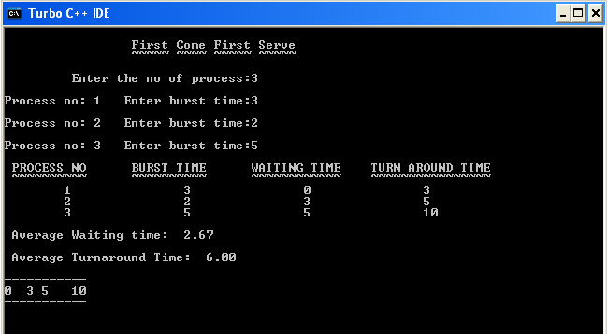

RESULT
Thus the program was executed successfully and the output was shown and verified.
EX: NO: 6(B) SHORTEST JOB FIRST
AIM
To simulate one of the CPU scheduling algorithm, Shortest Job First scheduling using C program.
ALGORITHM
Step1: Start the program.
Step 2: Read the number of process.
Step 3: Read the Execution time for each process.
Step 4: Sort the process according to their execution time in ascending order.
Step5: Calculate the waiting time of each processes and the average waiting time as,
Avg. waiting time = (waiting time of all process)/number of processes.
Step6: Calculate the average turn around time as,
Avg. turn around time = (Turn around time of all process)/number of processes.
Step7: Display the waiting time and turn around time for each process.
Step8: Display the Average waiting time and Average turn around time.
Step9: Display the result by using Gantt chart
Step10: End the program.

SOURCE CODE:
#include<stdio.h>
#include<conio.h>
#define MAX 50
struct process
{
int pro;
int brt;
int tt;
int wt;
}pr[MAX];
// Main program
int main()
{
int i,j,n,t,totwt,tottt;
float avgwt,avgtt;
int prevtt;
clrscr();
printf("\n\t\t\t SHORTEST JOB FIRST");
printf("\n\n Enter the no of process:");
scanf("%d",&n);
//Getting Process no. and Burst Time
for(i=1;i<=n;i++)
{
pr[i].pro = i;
printf("\nProcess no: %d ",pr[i].pro);
printf("\nEnter burst time:");
scanf("%d",&pr[i].brt);
}
// Sorting the Burst Time in Ascending order
for(i=1;i<=n;i++)
{
for(j=i+1;j<=n;j++)
{
if(pr[i].brt> pr[j].brt)
{
t= pr[j].pro;
pr[j].pro= pr[i].pro;
pr[i].pro=t;

t= pr[j].brt;
pr[j].brt= pr[i].brt;
pr[i].brt=t;
}
}
}
//calculating Waiting time and Turn Aruond Time
prevtt =0;
for(i=1;i<=n;i++)
{
pr[i].wt=prevtt;
pr[i].tt=pr[i].wt+pr[i].brt;
prevtt = pr[i].tt;
}
//Sum of Waiting time and Turn Aruond Time
printf("\n PROCESS NO \t BURST TIME \t WAITING TIME \t TURN AROUND TIME");
printf("\n ------------- \t ------------- \t---------- \t --------------");
totwt=0;
tottt=0;
for(i=1;i<=n;i++)
{
printf("\n\t%d\t\t%d\t\t%d\t\t%d",pr[i].pro,pr[i].brt,pr[i].wt,pr[i].tt);
totwt=totwt+pr[i].wt;
tottt=tottt+pr[i].tt;
}
//Average of Waiting time and Turn Aruond Time
avgwt=(float)totwt/n;
avgtt=(float)tottt/n;
printf("\n\n Average Waiting time:%6.2f",avgwt);
printf("\n\n Average Turnaround Time:%6.2f\n\n",avgtt);
// Top Line
for(i=0;i<=pr[n].tt;i++)
{
printf("-");
}
printf("\n");
//Gantt Chart
j=pr[1].wt;
printf("%d",j);
for(i=1;i<=n;i++)
{
printf("%*d",pr[i].brt,pr[i].tt);
}
printf("\n");
// Bottom Line
for(i=0;i<=pr[n].tt;i++)
{
printf("-");
}
printf("\n");
getch();
return 0;
}

OUTPUT :
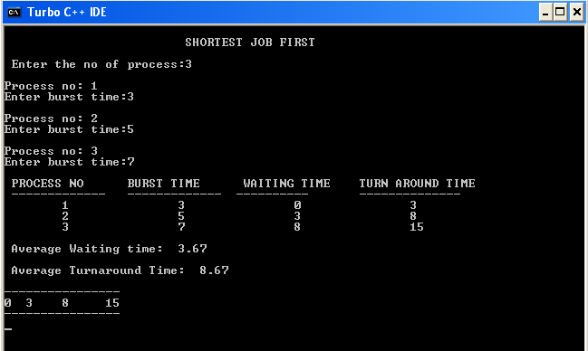

RESULT
Thus the program was executed successfully and the output was shown and verified.
EX: NO: 6(C) PRIORITY SCHEDULING
AIM
To simulate one of the CPU scheduling algorithms, Priority scheduling using C program.
ALGORITHM
Step1: Start the program.
Step2: Read the number of processes.
Step3: Get the Execution time (Burst time) and priority for each process.
Step4: Sort the processes based on their priority.
Step5: Calculate the waiting time of each process and the Average waiting as
Avg. waiting time = (waiting time of all processes)/number of processes.
Step6: Calculate the turn around time of each process and Average turn around time as
Avg. turn around time = (Turn around time of all processes)/number of process.
Step7: Display the arrival, waiting time and turn around time for each process.
Step 8: Display the Average waiting time and average turn around time.
Step9: Display the result by using Gantt chart
Step 10: End processing.
SOURCE CODE:
#include<stdio.h>
#include<conio.h>
#define MAX 50
struct process
{
int pro;
int brt;
int tt;
int wt;
int pri;
}pr[MAX];
// Main program
int main()
{
int i,j,n,t,totwt,tottt;
float avgwt,avgtt;
int prevtt;
clrscr();
printf("\n\t\t\t PRIORITY SCHEDULING");
printf("\n\n Enter the no of process:");
scanf("%d",&n);
//Getting Process no. and Burst Time
for(i=1;i<=n;i++)
{
pr[i].pro = i;
printf("\nProcess no: %d ",pr[i].pro);
printf("\nEnter burst time:");
scanf("%d",&pr[i].brt);
printf("\nEnter Priority:");
scanf("%d",&pr[i].pri);
}
// Sorting the Priority in Ascending order
for(i=1;i<=n;i++)
{
for(j=i+1;j<=n;j++)
{
if(pr[i].pri> pr[j].pri)
{
t= pr[j].pro;
pr[j].pro= pr[i].pro;
pr[i].pro=t;

t= pr[j].brt;
pr[j].brt= pr[i].brt;
pr[i].brt=t;

t= pr[j].pri;
pr[j].pri= pr[i].pri;
pr[i].pri=t;
}
}
}
//calculating Waiting time and Turn Aruond Time
prevtt =0;
for(i=1;i<=n;i++)
{
pr[i].wt=prevtt;
pr[i].tt=pr[i].wt+pr[i].brt;
prevtt = pr[i].tt;
}
//Sum of Waiting time and Turn Aruond Time
printf("\n PROCESS NO \t BURST TIME \t WAITING TIME \t TURN AROUND TIME");
printf("\n ------------- \t ------------- \t---------- \t --------------");
totwt=0;
tottt=0;
for(i=1;i<=n;i++)
{
printf("\n\t%d\t\t%d\t\t%d\t\t%d",pr[i].pro,pr[i].brt,pr[i].wt,pr[i].tt);
totwt=totwt+pr[i].wt;
tottt=tottt+pr[i].tt;
}
//Average of Waiting time and Turn Aruond Time
avgwt=(float)totwt/n;
avgtt=(float)tottt/n;
printf("\n\n Average Waiting time:%6.2f",avgwt);
printf("\n\n Average Turnaround Time:%6.2f\n\n",avgtt);
// Top Line
for(i=0;i<=pr[n].tt;i++)
{
printf("-");
}
printf("\n");
//Gantt Chart
j=pr[1].wt;
printf("%d",j);
for(i=1;i<=n;i++)
{
printf("%*d",pr[i].brt,pr[i].tt);
}
printf("\n");
// Bottom Line
for(i=0;i<=pr[n].tt;i++)
{
printf("-");
}
printf("\n");
getch();return 0;
}

OUTPUT:

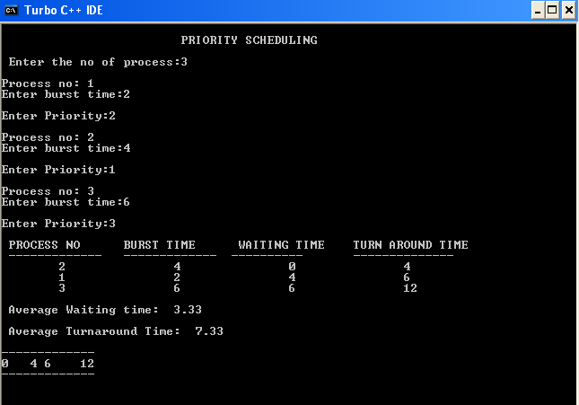

RESULT
Thus the program was executed successfully and the output was shown and verified.

EXNO: 6(D) ROUND ROBIN SCHEDULING ALGORITHM

AIM:
To simulate one of the CPU scheduling algorithms, Round robin scheduling using C program.
ALGORITHM:

Step 1: Start the program.
Step 2: Get the total number of processes and time slice from the user.
Step 3: Get the burst time for every process from the user.
Step 4: Initialize the total turnaround time to 0.
Step 5: calculate the total turnaround time and remaining time of each process for every iteration using the below statements,
tottt = tottt + ts;
pr[i].remtime = pr[i].remtime - ts;
Step 6: Calculate the total waiting time and turnaround time and its average.
Step 7: Display average waiting time and average turnaround time to the user.
Step 8: Stop the program.

PROGRAM:
#include<stdio.h>
#include<conio.h>
#define MAX 50
struct process
{
int pro;
int brt;
int tt;
int wt;
int remtime;
}pr[MAX];
// Main program
void main()
{
int i,j,n,t,totwt,tottt;
float avgwt,avgtt;
int ts;
int totbrt;
printf("\n Enter the no of process:");
scanf("%d",&n);
printf("\nEnter the time slice:");
scanf("%d",&ts);
//Getting Process no. and Burst Time
totbrt = 0;
for(i=1;i<=n;i++)
{
printf("\nEnter process no: %d \n", i);
pr[i].pro = i;
printf("\nEnter burst time:");
scanf("%d",&pr[i].brt);
pr[i].remtime = pr[i].brt;
totbrt = totbrt + pr[i].brt;
}
//calculating Waiting time and Turn Aruond Time
tottt = 0;
while (1)
{
if(tottt == totbrt)
{
break;
}
for(i=1;i<=n;i++)
{
if(pr[i].remtime == 0)
{
continue;
}
if(pr[i].remtime > ts)
{
tottt = tottt + ts;
pr[i].remtime = pr[i].remtime - ts;
}
else
{
tottt = tottt + pr[i].remtime;
pr[i].remtime = 0;
}
pr[i].wt = tottt-pr[i].brt;
pr[i].tt = tottt;
}
}
//Sum of Waiting time and Turn Aruond Time
printf("\n PROCESS NO \t BURST TIME \t WAITING TIME \t TURN AROUND TIME");
printf("\n ------------- \t ------------- \t---------- \t --------------");
totwt=0;
tottt=0;
for(i=1;i<=n;i++)
{
printf("\n\t%d\t\t%d\t\t%d\t\t%d",pr[i].pro,pr[i].brt,pr[i].wt,pr[i].tt);
totwt=totwt+pr[i].wt;
tottt=tottt+pr[i].tt;
}
//Average of Waiting time and Turn Aruond Time
avgwt=(float)totwt/n;
avgtt=(float)tottt/n;
printf("\n\n Average Waiting time:%6.2f",avgwt);
printf("\n\n Average Turnaround Time:%6.2f",avgtt);
getch();
}

OUTPUT

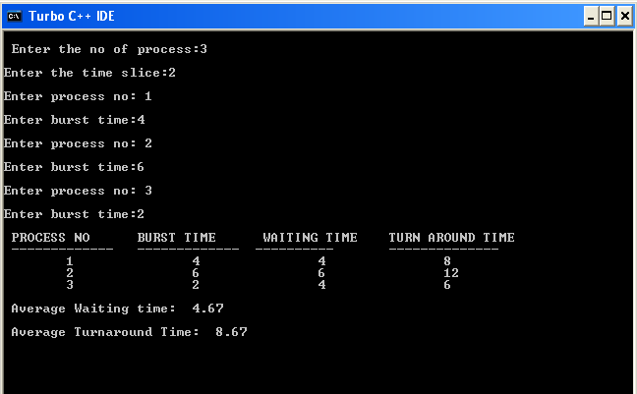

RESULT
Thus the given program is executed successfully and the output was shown and verified.
SYNCHRONIZATION PROBLEMS USING SEMAPHORE

EX: NO:7 (DINING PHILOSOPHERS PROBLEM)
AIM:
To implement one of the synchronisation problem, dining philosophers problem using semaphores.

ALGORITHM:

- Start the program.
- Initialise the number of philosophers to 5.
- Set all the philosophers status into thinking state.
- Get the choice from the user, about which philosopher is going to eat.
- Change the state of the philosopher into hungry by calling take_sticks function.
- Check the state of the neighbours by calling test function, if the right and left chopsticks are
available change the state from hungry to eating, otherwise it remains in the hungry state.
- Repeat the above steps for remaining philosophers.
- To stop eating, call the put_sticks function, it changes the state of the philosopher from eating to
thinking.
- If any of the philosopher is in hungry state, will start eating after availing the chopsticks of the
neighbours.
- Stop the program

SOURCE CODE

#include<stdio.h>
#include<conio.h>
#define N 5
#define LEFT (j-1)%N
#define RIGHT (j+1)%N
#define THINKING 0
#define HUNGRY 1
#define EATING 2
int state[N];
void test(int);
int lt, rt;
void main()
{
int f,ch=0,i,a,b;
int take_sticks(int);
int put_sticks(int);
clrscr();
printf("\n \t *** DINING PHILOSOPHER PROBLEM**\n");
printf("ENTER THW NUMBER OF PHILOSOPHER IN THE TABLE IS %d:",N);
printf("\n STATUS OF THE PHILOSOPHER:\n");
for(i=0;i<N;i++)
{
state[i]=THINKING;
printf("\n P%d IS THINKING",i);
}
do
{
printf("\n\t\t MENU\n\n");
printf("\n\t1.START EATING\n\n");
printf("\n\t2.STOP EATING\n\n");
printf("\n\t3.EXIT\n\n");
printf("ENTER YOUR CHOICE:");
scanf("%d",&ch);
switch(ch)
{
case 1:
printf("\n ENTER THE PHILOSOPHER WHO IS GOING TO EAT:");
scanf("%d",&a);
f=take_sticks(a);
if(f==EATING)
{
printf("\n THE PHILOSOPHER HAS STARTED EATING...\n\n");
}
else
{
printf("\nTHE PHILOSOPHER IS HUNGRY!!..\n\n");
printf("\n THE CHOPSTICK IS ENGAGED\n\n");
}
for(i=0;i<N;i++)
{
if(state[i]==THINKING)
{
printf("\nP%d IS THINKING",i);
}
else if(state[i]==HUNGRY)
{
printf("\nP%d IS HUNGRY",i);
}
else
{
printf("\nP%d IS EATING",i);
}
}
break;
case 2:
printf("\n ENTER THE PHILOSOPHER NUMBER TO RELEASE THE CHOPSTICK");
scanf("%d",&b);
if(state[b]==EATING)
{
f=put_sticks(b);
printf("\n THE PHILOSOPHER HAS STOPPED EATING!!..\n\n");
}
else
{
printf("\n THE PHILOSOPHER IS NOT EATING!!\n\n");
}
for(i=0;i<N;i++)
{
if(state[i]==THINKING)
{
printf("\nP%d IS THINKING",i);
}
else if(state[i]==HUNGRY)
{
printf("\nP%d IS HUNGRY",i);
}
else
{
printf("\nP%d IS EATING",i);
}
}
break;
case 3:
exit(0);
break;
}
}
while(ch!=3);
getch();
}
int take_sticks(int j)
{
state[j]=HUNGRY;
test(j);
return state[j];
}
int put_sticks(int j)
{
state[j]=THINKING;
if(j==0) test(N-1); else test(LEFT);
if(j==N-1) test(0); else test(RIGHT);
return state[j];
}
void test(int j)
{
if(j==0) rt = N-1; else rt = LEFT;
if(j==N-1) lt = 0; else lt = RIGHT;
if(state[j]==HUNGRY && state[lt]!=EATING && state[rt]!=EATING)
{
state[j]=EATING;
}
}

OUTPUT
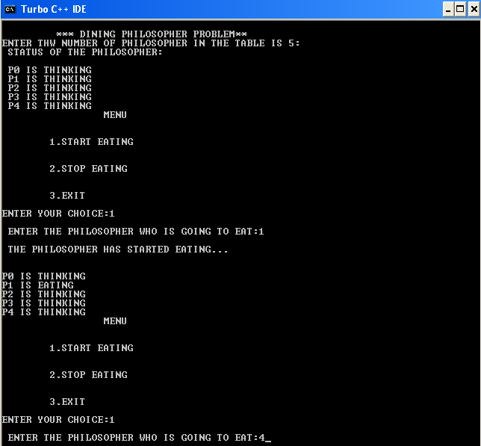
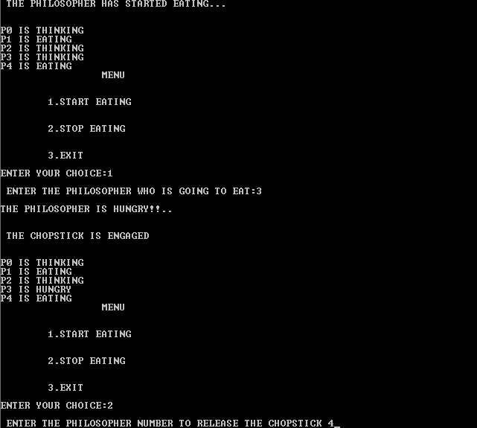
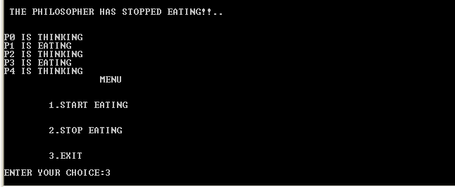

RESULT
Thus the given program is executed successfully and the output was shown and verified.

.
MEMORY MANAGEMENT

EX: NO:8(A) BEST FIT
AIM
To simulate one of the memory management technique, best fit algorithm using C program.
ALGORITHM
Step1: Start the program.
Step2: Get the number of process and memory blocks from the user.
Step3: Get the size of each processes and size of each memory blocks available.
Step4: Find the memory block which is perfectly utilized for each process without wasting of large memory space.
Step5: Then allocate each process to memory blocks.
Step6: If the memory is insufficient don’t allocate the process.
Step 7: Display the allocation of processes.
Step 8: Stop the program.
PROGRAM
#include<stdio.h>
#include<process.h>
void main()
{
int m[20],p[20],i,j,np,nm, pos, min;
clrscr();
printf("\t\t\t******* Best Fit******\n");
// Read Process details
printf("Enter number of Process\n");
scanf("%d",&np);
for(i=0;i<np;i++)
{
printf("Enter the size of %d Process: ",i+1);
scanf("%d",&p[i]);
}
// Read Memory details
printf("\nEnter number of Memory Blocks\n");
scanf("%d",&nm);
for(i=0;i<nm;i++)
{
printf("Enter the %d Block size: ",i+1);
scanf("%d",&m[i]);
}
for(i=0;i<np;i++)
{
min = 9999;
for(j = 0; j < nm; j++)
{
if(min > m[j] && p[i] <= m[j])
{
min = m[j];
pos = j;
}
}
if (min != 9999)
{
printf("\nThe Process %d allocated to Block %d\n",i+1,pos+1);
m[pos] = m[pos] - p[i];
p[i]=10000;
}
}
for(i=0;i<np;i++)
{
if(p[i]!=10000)
{
printf("The Process %d is not allocated \n",i+1);
}
}
getch();
}

OUTPUT:
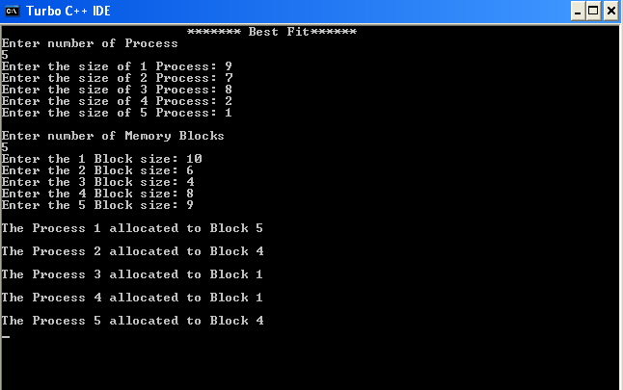

RESULT
Thus the given program is executed successfully and the output was shown and verified.

EX: NO: 8(B) FIRST FIT
AIM
To simulate one of the memory management technique, first fit algorithm using C program.
ALGORITHM
Step1: Start the program.
Step2: Get the number of process and memory blocks from the user.
Step3: Get the size of each processes and size of each memory blocks available.
Step4: Find the memory block which is perfectly utilized for each process without wasting of large memory space.
Step5: Then allocate each process to memory blocks.
Step6: If the memory is insufficient don’t allocate the process.
Step 7: Display the allocation of processes.
Step 8: Stop the program.
SOURCE CODE:
#include<stdio.h>;
#include<process.h>;
void main()
{
int m[20],p[20],i,j,np,nm;
clrscr();
printf("\t\t\t******* First Fit******\n");
// Read Process details
printf("Enter number of Process\n");
scanf("%d",&np);
for(i=0;i<np;i++)
{
printf("Enter the size of %d Process: ",i+1);
scanf("%d",&p[i]);
}
// Read Memory details
printf("\nEnter number of Memory Blocks\n");
scanf("%d",&nm);
for(i=0;i<nm;i++)
{
printf("Enter the %d Block size: ",i+1);
scanf("%d",&m[i]);
}
// Allocate Memory
for(i=0;i<np;i++)
{
for(j=0;j<nm;j++)
{
if(p[i]<=m[j])
{
printf("\nThe Process %d allocated to Block %d\n",i+1,j+1);
m[j] = m[j] - p[i];
p[i]=10000;
break;
}
}
}
for(i=0;i<np;i++)
{
if(p[i]!=10000)
{
printf("The Process %d is not allocated \n",i+1);
}
}} getch();

OUTPUT
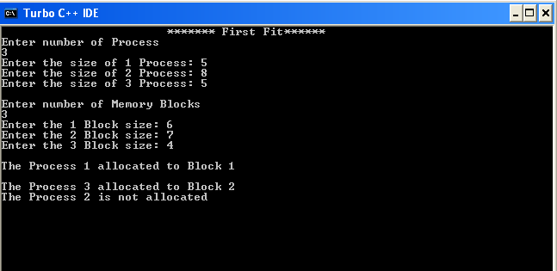

RESULT
Thus the given program is executed successfully and the output was shown and verified.

EX: NO: 8(C) WORST FIT

AIM
To simulate one of the memory management technique, worst fit algorithm using C program.

ALGORITHM

Step1: Start the program.
Step2: Get the number of process and memory blocks from the user.
Step3: Get the size of each processes and size of each memory blocks available.
Step4: Sort the processes and memory blocks.
Step5: Find the memory block which is having very large space and allocate the least process.
Step6: Then allocate each process to memory blocks.
Step7: If the memory is insufficient don’t allocate the process.
Step 8: Display the allocation of processes.
Step 9: Stop the program.

SOURCE CODE:
#include<stdio.h>
#include<process.h>
void main()
{
int m[20],p[20],i,j,np,nm, pos, max;
//clrscr();
printf("\t\t\t******* Worst Fit******\n");
// Read Process details
printf("Enter number of Process\n");
scanf("%d",&np);
for(i=0;i<np;i++)
{
printf("Enter the size of %d Process: ",i+1);
scanf("%d",&p[i]);
}
// Read Memory details
printf("\nEnter number of Memory Blocks\n");
scanf("%d",&nm);
for(i=0;i<nm;i++)
{
printf("Enter the %d Block size: ",i+1);
scanf("%d",&m[i]);
}
for(i=0;i<np;i++)
{
max = -1;
for(j = 0; j < nm; j++)
{
if(max < m[j] && p[i] <= m[j])
{
max = m[j];
pos = j;
}
}
if (max != -1)
{
printf("\nThe Process %d allocated to Block %d\n",i+1,pos+1);
m[pos] = m[pos] - p[i];
p[i]=10000;
}
}
for(i=0;i<np;i++)
{
if(p[i]!=10000)
{
printf("The Process %d is not allocated \n",i+1);
}
}
getch();
}

OUTPUT
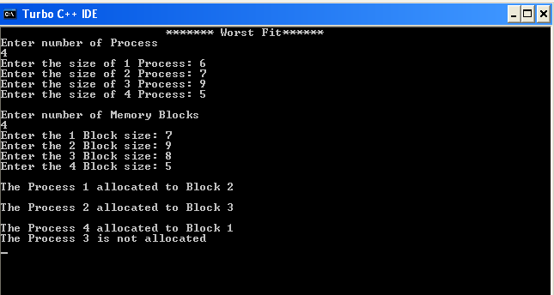

RESULT
Thus the given program is executed successfully and the output was shown and verified.

EX: NO: 9(A) SIMULATION OF VIRTUAL MEMORY MANAGEMENT SCHEMES.
PAGE REPLACEMENT ALGORITHM
FIRST IN FIRST OUT
AIM
To simulate one of the virtual memory management technique, FIFO algorithm using C program.

ALGORITHM
- Start the program
- Using the getdata() function, get the number of frames(nf), number of elements(ne) and the
reference string using ref[] array.
- Initialize all the frames to -1 in frame (fr[]) array, to indicate it is empty.
- Insert each elements from the ref[] array into fr[] array one by one, by checking the condition, if(rear==nf-1) also increment the miss value(page fault).
- If the elements already exists in the fr[] array, increment the hit value.
- Display the number of hits and page faults.
- Stop the program.

SOURCE CODE
#include<stdio.h>
#include<conio.h>
int nf;
int ne;
int hit,miss;
int ref[50];
int fr[15];
void getdata();
void fifo();
int large(int []);
void getdata()
{
int i;
printf("\nEnter the number of frames:");
scanf("%d",&nf);
printf("\nEnter the number of elements in the reference string:\n");
scanf("%d",&ne);
printf("\nEnter the reference string:\n");
for(i=0;i<ne;i++)
{
scanf("%d",&ref[i]);
}
}
void fifo()
{
int i,j,found=0,rear=-1;
miss=hit=0;
for(i=0;i<nf;i++)
{
fr[i]=-1;
}
for(i=0;i<ne;i++)
{
printf("\nThe no to be inserted :%d",ref[i]);
found=search(ref[i]);
if(found==0)
{
miss++;
if(rear==nf-1)
{
rear=-1;
}
rear++;
fr[rear]=ref[i];
}
else
{
hit++;
}
printf("\n");
for(j=0;j<nf;j++)
printf("%d ",fr[j]);
}
printf("\n\n No. of page faults=%d\n",miss);
printf("\n No. of Hits=%d",hit);
}
int search(int item)
{
int i;
for(i=0;i<nf;i++)
{
if(fr[i]==item)
{
return(1);
}
}
return 0;
}
void main()
{
clrscr();
printf("\n\t\t\t FIFO PAGE REPLACEMENT");
getdata();
printf("\t\t\t FIFO PAGE REPLACEMENT");
fifo();
getch();
}

OUTPUT
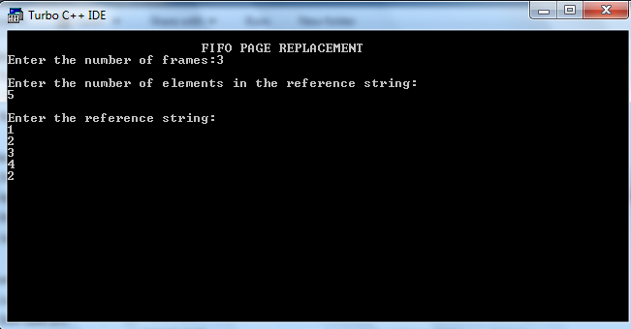
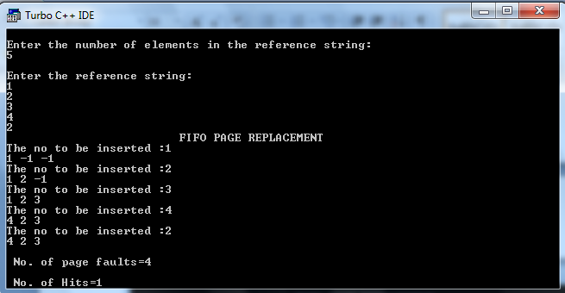
RESULT
Thus the given program is executed successfully and the output was shown and verified.
EX: NO: 9(B) LEAST RECENTLY USED

AIM
To simulate one of the virtual memory management technique, LRU algorithm using C program.

ALGORITHM
- Start the program
- Using the getdata() function, get the number of frames(nf), number of elements(ne) and the
reference string using ref[] array.
- Initialize all the frames to -1 in frame (fr[]) array, to indicate it is empty.

- If the elements already exists in the fr[] array, increment the hit value.
- Display the number of hits and page faults.
- Stop the program.

SOURCE CODE

#include<stdio.h>
int nf;
int i,ne;
int miss=0;
int ref[50];
int fr[15];
void getdata();
void lru();
void getdata()
{
printf("\nEnter the number of frames:");
scanf("%d",&nf);
printf("\nEnter the number of elements in the reference string:\n");
scanf("%d",&ne);
printf("\nEnter the reference string:\n");
for(i=0;i<ne;i++)
{
scanf("%d",&ref[i]);
}
}
void lru()
{
int check,j,k;
int count=0,index[5];
printf("\n\n Simulation of LRU page replacement technique!...........\n");
for(i=0;i<nf;i++)
{
fr[i]=-1;
}
for(i=0;i<ne;i++)
{
check=0;
for(j=0;j<nf;j++)
{
if(fr[j]==ref[i])
{
check=1;
}
}
if(check==0)
{
miss+=1;
if(count<nf)
{
fr[count++] = ref[i];
}
else
{
for(j=0;j<i;j++)
{
for(k=0;k<nf;k++)
{
if(ref[j]==fr[k])
{
index[k] = j;
}
}
}
for(j=0;j<nf;j++)
{
if(index[check]>index[j])
{
check=j;
}
}
fr[check]=ref[i];
}
printf("\n");
for(j=0;j<nf;j++)
{
printf("%d\t",fr[j]);
}
}
}
printf("\n Number of page faults:%d",miss);
}
void main()
{
clrscr();
printf("\n\t\t\t LRU PAGE REPLACEMENT");
getdata();
printf("\t\t\t LRU PAGE REPLACEMENT");
lru();
getch();
}

OUTPUT
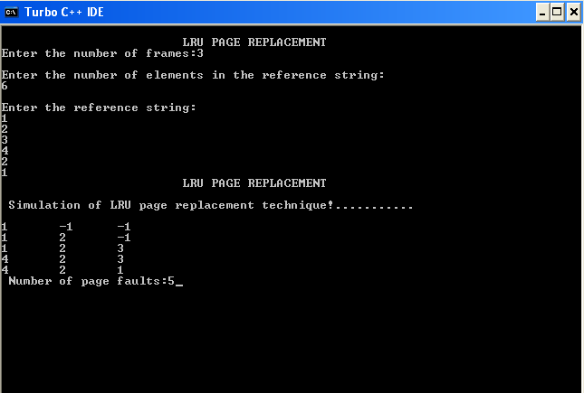

RESULT
Thus the given program is executed successfully and the output was shown and verified.

DISK SCHEDULING ALGORITHM
EX: NO: 10(A) FIRST COME FIRST SERVE

AIM
To simulate first come first serve disk scheduling algorithms using C program.

ALGORITHM
- Start the program
- Get the number of requests(req) from the user.
- Get the current header position(cpo) from the user.
- Get all the requests from the user using cyp[] array.
- Find the current header position in the sorted array to initiate the scheduling.
- Set the next position (npo) to next element in an array.
- Calculate the total moves (tmov), by calculating the difference between npo and cpo.
- Change the current position to next position,
- Change the next position to next element in the array.
- Then set the cpo to 0, repeat the above process till it reaches the initial header position.
- Print the total moves by the header
- Stop the program

SOURCE CODE:

#include<stdio.h>
void main()
{
int q[20],r,h,i,j,sk=0,d;
printf("\t\t\tFirst Come First Serve Disk Scheduling Algorithm\n");
printf("\nEnter the number of request:");
scanf("%d",&r);
printf("Enter the Request:\t\n");
for(i=1;i<=r;i++)
{
scanf("%d",&q[i]);
}
printf("Enter the head position:");
scanf("%d",&h);
q[0]=h;
printf("\n");
for(j=0;j<=r-1;j++)
{
d=abs(q[j]-q[j+1]);
sk+=d;
printf("Head Moves from %d to %d with Seek %d\n",q[j],q[j+1],d);
}
printf("\nTotal Seek Time is %d\t",sk);
}

OUTPUT:
First Come First Serve Disk Scheduling Algorithm

Enter the number of request:4
Enter the Request:

5
2
1
6
Enter the head position:4

Head Moves from 4 to 5 with Seek 1
Head Moves from 5 to 2 with Seek 3
Head Moves from 2 to 1 with Seek 1
Head Moves from 1 to 6 with Seek 5

Total Seek Time is 10

RESULT:
Thus the first come first serve disk scheduling program has implemented successfully.
EX: NO: 10(B) SHORTEST SEEK TIME FIRST

AIM
To simulate shortest seek time first disk scheduling algorithms using C program.

ALGORITHM
- Start the program
- Get the number of requests(req) from the user.
- Get the current header position(cpo) from the user.
- Get all the requests from the user using cyp[] array.
- Find the current header position in the sorted array to initiate the scheduling.
- Set the next position (npo), the shortest seek time is selected to next element in an array.
- Calculate the total moves (tmov), by calculating the difference between npo and cpo.
- Change the current position to next position,
- Change the next position to next element in the array.
- Then set the cpo to 0, repeat the above process till it reaches the initial header position.
- Print the total moves by the header
- Stop the program

SOURCE CODE:

#include<stdio.h>
int i,j,r,tmov=0,h,npo;
int q[20],temp,pos;
void SSTF(int h)
{
int min = 200, diff;
for(j = h+1; j <= r; j++)
{
diff = abs(q[h] - q[j]);
if(min > diff)
{
min = diff;
pos = j;
}
}
temp = q[pos];
for (j = pos; j > h+1; j--)
{
q[j] = q[j-1];
}
q[h+1] = temp;
if(h < r)
{
SSTF(h+1);
}
}
void main()
{
printf("\t\t\t Shortest Seek Time First Disk Scheduling\t\t\t\n");
printf("\n Enter the number of requests : ");
scanf("%d",&r);
printf("\n Enter the Requests : \n");
for(i=1;i<=r;i++)
{
scanf("%d",&q[i]);
}
printf("\n Enter the current header position : ");
scanf("%d",&h);
q[0] = h;
SSTF(0);
h = q[0];
for(j = 1; j <= r; j++)
{
npo = q[j];
tmov += (abs(h-npo));
printf("Head Moves from %d to %d with %d\n", h, npo, abs(h-npo));
h = npo;
}
printf("Total Seek Time is %d", tmov);
}

OUTPUT:
Shortest Seek Time First Disk Scheduling

Enter the number of requests : 4

Enter the Requests :

5
2
1
6

Enter the current header position : 4
Head Moves from 4 to 5 with 1
Head Moves from 5 to 6 with 1
Head Moves from 6 to 2 with 4
Head Moves from 2 to 1 with 1
Total Seek Time is 7

RESULT:
Thus the shortest seek time first disk scheduling program has implemented successfully

EX: NO: 10(C) SCAN

AIM
To simulate one of the disk scheduling algorithms, SCAN using C program.

ALGORITHM:
- Start the program
- Set the size of the disk(cymax) to 199.
- Get the number of requests(req) from the user.
- Get the current header position(cpo) from the user.
- Get all the requests from the user using cyp[] array.
- Sort the requests in ascending order.
- Find the current header position in the sorted array to initiate the scheduling.
- Set the next position (npo) to next element in an array.
- Calculate the total moves (tmov), by calculating the difference between npo and cpo.
- Change the current position to next position,
- Change the next position to next element in the array.
- If the cpo reaches the end of the array, assign the npo to cymax.
- Then set the cpo to 0, repeat the above process till it reaches the initial header position.
- Print the total moves by the header
- Stop the program

SOURCE CODE:

#include<stdio.h>
#define cymax 199
int i,j,r,tmov=0,cp,h,npo;
int q[20],temp,tmp;
void SCAN()
{
int ind = 0;
int end = r + 2;
int prev;
for(i=0;i<=end;i++)
{
for(j=0;j<end-i;j++)
{
if(q[j] > q[j+1])
{
temp = q[j];
q[j] = q[j+1];
q[j+1] = temp;
}
}
}
cp=0;
do
{
if(q[cp] == h)
{
break;
}
cp++;
}while(cp!=end);
tmp = cp;
i=0;
h = q[cp];
do
{
if(ind == 0)
{
if(cp == 0)
{
cp = tmp;
npo = q[++cp];
ind = 1;
}
else
{
npo = q[--cp];
}
}
else
{
npo = q[++cp];
}
if(npo != cymax)
{
printf("Head Moves from %d to %d with %d\n",h,npo,abs(h-npo));
tmov += (abs(h-npo));
}
h = npo;
}while(npo!=q[end]);
printf(" Total Seek Time is %d",tmov);
}

void main()
{
printf("\t\t\t SCAN Scheduling\t\t\t\n");
printf("\n Enter the number of requests : ");
scanf("%d",&r);
printf("\n Enter the Requests : \n");
for(i=1;i<=r;i++)
{
scanf("%d",&q[i]);
}
q[i++] = 0;
q[i] = cymax;
printf("\n Enter the current header position : ");
scanf("%d",&h);
q[0] = h;
SCAN();

}

OUTPUT:

SCAN Scheduling

Enter the number of requests : 4

Enter the Requests :
5
2
1
6

Enter the current header position : 4
Head Moves from 4 to 2 with 2
Head Moves from 2 to 1 with 1
Head Moves from 1 to 0 with 1
Head Moves from 0 to 5 with 5
Head Moves from 5 to 6 with 1
Total Seek Time is 10

RESULT:
Thus the scan disk scheduling program has implemented successfully.

